Programming & Data Structures

Week 10 Assignment

**Question 1)**

Given the following sequence of numbers add to a hash table with 8 entries, and a hash

function of h(x) = x % 8, show the contents of the hash using:

a) Chaining

b) Linear probing

c) Quadratic probing (c1 = ½, c2 = ½)

d) Double hashing (with h2(x) = 7 - x % 7).

**Sequence:** 17, 23, 100, 50, 61, 9, 12, 15, 6, 4, 33, 27, 51

1. Chaining

|  |  |  |  |  |  |  |  |
| --- | --- | --- | --- | --- | --- | --- | --- |
|  | 17 | 50 | 27 | 100 | 61 | 6 | 23 |
|  | 9 |  | 51 | 12 |  |  | 15 |
|  | 33 |  |  | 4 |  |  |  |

1. Linear Probing

|  |  |  |  |  |  |  |  |
| --- | --- | --- | --- | --- | --- | --- | --- |
| 15 | 17 | 50 | 9 | 100 | 61 | 12 | 23 |

1. Quadratic Probing (c1 = ½, c2 = ½). Offset chart: 1, 3, 6, 10, 15

|  |  |  |  |  |  |  |  |
| --- | --- | --- | --- | --- | --- | --- | --- |
| 15 | 17 | 50 | 12 | 100 | 61 | 9 | 23 |

1. Double Hashing (h2(x) = 7 – (x % 7)).

|  |  |  |  |  |  |  |  |
| --- | --- | --- | --- | --- | --- | --- | --- |
| 12 | 17 | 50 | 15 | 100 | 61 | 9 | 23 |

**Question 2)**

Use the graph below to answer the following questions:



1. Depict the adjacency matrix for the graph above.

|  |  |  |  |  |  |  |  |  |
| --- | --- | --- | --- | --- | --- | --- | --- | --- |
|  | A | B | C | D | E | F | G | H |
| A | 0 | 0 | 1 | 0 | 1 | 0 | 0 | 0 |
| B | 0 | 0 | 0 | 1 | 1 | 0 | 0 | 0 |
| C | 0 | 0 | 0 | 0 | 1 | 1 | 0 | 0 |
| D | 0 | 0 | 0 | 0 | 1 | 0 | 0 | 0 |
| E | 0 | 0 | 0 | 0 | 0 | 0 | 1 | 0 |
| F | 0 | 0 | 0 | 0 | 0 | 0 | 0 | 1 |
| G | 0 | 1 | 0 | 0 | 0 | 0 | 0 | 0 |
| H | 0 | 0 | 0 | 0 | 0 | 1 | 0 | 0 |

b) Depict the adjacency list for the graph above.

A → E → C

B → E → D

C → E → F

D → E

E → G

F → H

G → B

H → F

c) How many connected components are there in the graph?

It does not make sense to talk about a directed graph being connected or not connected because there may be a path from node "i" to node "j" in a directed graph where there is no reciprocal path from node "j" to node "i".

(If this was an undirected graph, there would be one connected component to the graph)

.

d) Run a DFS from B and state the sequence of nodes.

B, D, E, G

e) Run a BFS from E and state the sequence of nodes.

E, G, B, D

f) Are there cycles in the above graph? Identify all that you can find.

There are 3 cycles.

F, H

E, G, B

E, G, B, D

Breadth-First Search Example:

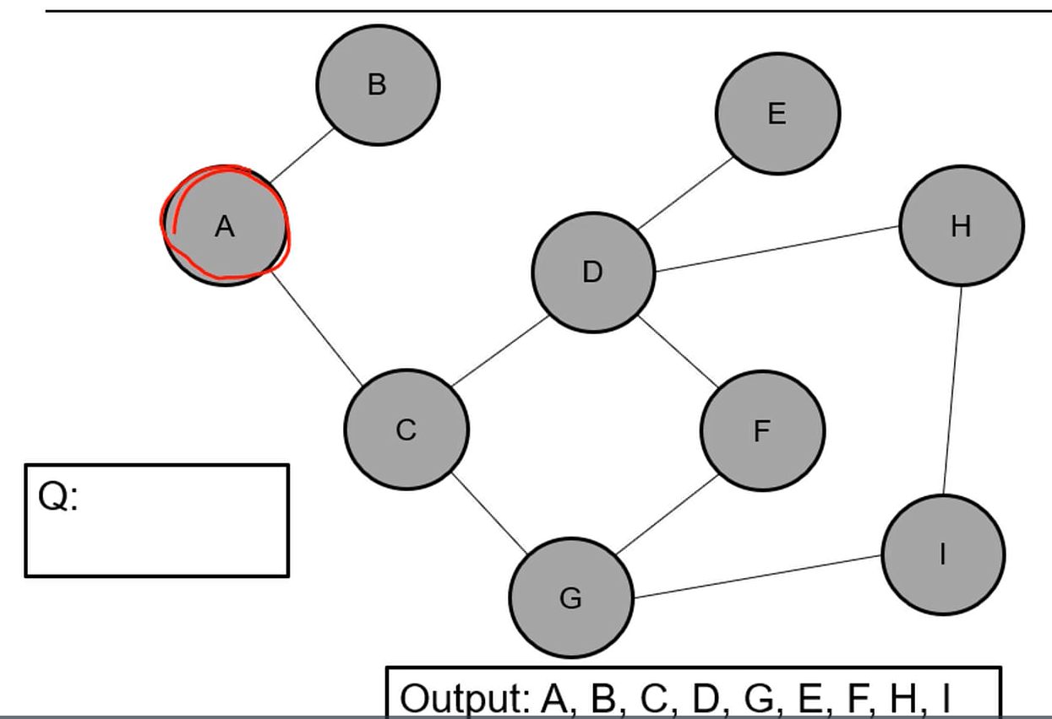

Depth-First Search Example

